**NAAN MUTHALVAN PROJECT**

**PROJECT TITLE: EXPLORING THE WORLD’S TOP YOUTUBE CHANNELS**

**TEAM LEADER TEAM MEMBERS**

**RIJUTHA.D(211520243045) ANUROOPA.PV(211520243004)**

**SWETHA.S (211520243057)**

**NAJEETHA BANU.N(211520243033)**

1. **INTRODUCTION**

**1.1** PROJECT OVERVIEW**:**

In this project, we aim to explore the diverse and dynamic landscape of YouTube channels. YouTube is a global platform with millions of content creators and viewers. Our objective is to investigate, analyze, and gain insights into the various channels, content genres, audience engagement, and the broader impact of YouTube on digital culture.

**KEY OBJECTIVE:**

1. Channel Categorization: Categorize and classify YouTube channels based on content genres, target audience, and geographical regions.

2. Data Collection: Collect data from YouTube channels, including video content, view counts, subscribers, and engagement metrics.

3. Data Analysis: Analyze the collected data to identify trends, patterns, and correlations among different channel categories.

4. Audience Engagement: Examine the interaction between content creators and viewers, including comments, likes, and shares.

5. User Insights: Provide recommendations and insights for viewers seeking channels of interest.

* 1. PURPOSE OF THE PROJECT

The "Exploring the World of YouTube Channels" project serves as a comprehensive exploration of the dynamic and multifaceted YouTube platform. With the aim of better understanding digital culture, our project delves into the vast landscape of YouTube channels, categorizing them by content genre and providing valuable insights into trends and patterns. By analyzing audience engagement and sentiments, we shed light on the interactions between content creators and their viewers, offering practical guidance for content improvement. Additionally, the project endeavors to assess the broader societal and cultural impact of influential YouTube channels, examining how they influence consumer behavior and cultural phenomena. Through personalized user recommendations and a user-friendly platform, we seek to enhance the viewing experience for YouTube users. This project represents an endeavor to bridge the gap between the vast world of YouTube content and the viewers and creators who aim to navigate it effectively, while also contributing to the understanding of digital culture in the 21st century.

1. **LITERATURE SURVEY**

**2.1** EXISTING SYSTEM

The current system for navigating and engaging with YouTube channels predominantly relies on the YouTube platform itself, supplemented by third-party applications, analytics tools, and social media platforms. YouTube serves as the primary hub for channel discovery and interaction, allowing users to watch, subscribe, and engage with content. Creators and businesses turn to third-party analytics tools for in-depth insights into channel performance. Meanwhile, social media platforms serve as valuable tools for channel promotion and audience engagement. The YouTube Data API facilitates programmatic access to channel and video data, empowering developers to collect essential information. While these elements collectively enable channel exploration and engagement, the "Exploring the World of YouTube Channels" project aims to enhance the existing system by introducing more robust categorization, user-specific recommendations, and a comprehensive assessment of channel impact, thereby further enriching the YouTube experience for both creators and viewers.

* 1. REFERENCES

1. J. E. Lee and B. Watkins, "YouTube vloggers’ influence on consumer luxury brand perceptions and intentions", J. Bus. Res., vol. 69, no. 12, pp. 5753-5760, 2016.
2. M. Ramos-Serrano, M. and P. Herrero-Diz, "Unboxing and brands: YouTubers phenomenon through the case study of EvanTubeHD", Prisma social, no. 1, pp. 90-120, 2016.
3. M.L. Khan, "Social media engagement: What motivates user participation and consumption on YouTube?", Computers in Human Behavior, vol. 66, pp. 236-247, 2017.
4. Farzana Shaikh, Danish Pawaskar, Umar Khan and Abutalib Siddiqui, "YouTube Data Analysis on Hadoop", IEEE International Conference on Current Trends towards Converging Technologies (ICCTCT 2018), March 2018.
5. Adiyta Joshi, Jigar Shah, Nihaal Wagadia, Vineet Suthar and Vishakha Shelke, "Review of YouTube Data Analysis", International Journal of Recent Trends in Engineering & Research, vol. 6, no. 3, pp. 77-78, March 2017.
   1. PROBLEM STATEMENT DEFINITION

In the context of the "Exploring the World of YouTube Channels" project, the prevailing issues are two-fold. Firstly, the staggering volume of content available on YouTube poses a significant challenge for users trying to navigate this vast digital landscape. The absence of a comprehensive channel categorization system makes it cumbersome for viewers to pinpoint content that aligns with their specific interests. Secondly, the existing platform's recommendation system, while functional, often falls short in delivering highly personalized suggestions. This results in users potentially missing out on content that resonates with their preferences. Furthermore, understanding the depth of audience engagement, user sentiments, and the broader societal impact of YouTube channels remains an elusive aspect. Therefore, the project's fundamental challenge is to streamline content categorization, introduce more personalized recommendations, and offer a comprehensive analysis of user engagement, bridging the gap between YouTube's immense content library and user expectations for a more intuitive, insightful, and enriching digital content experience.

1. **IDEATHON AND PROPOSED SOLUTION**

3.1 Empathy set canvas

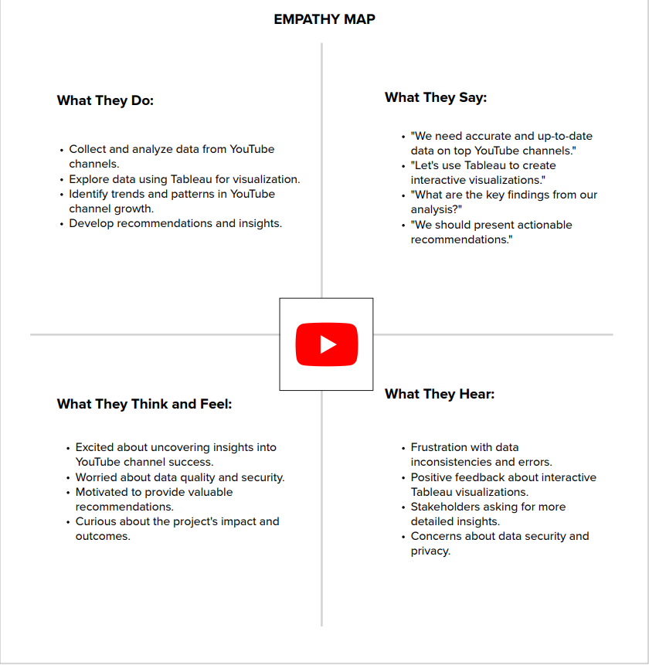

3.2 Ideathon and Brainstorming

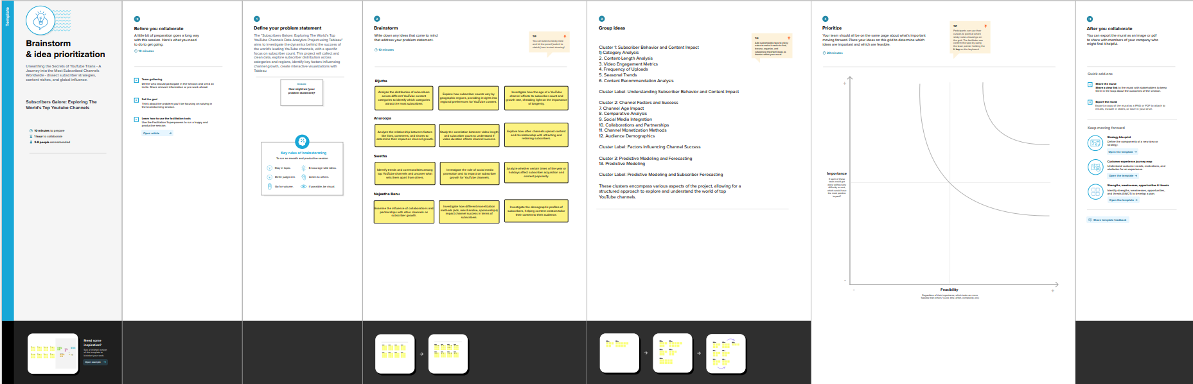

1. **REQUIREMENT ANALYSIS**

4.1 Functional Requirements

Functional requirements for the "Exploring the World of YouTube Channels" project outline the specific features and capabilities that the project's software or platform must possess to meet its objectives. Here are some functional requirements:

1.Channel Categorization:

* The system must categorize YouTube channels based on content genres, target audience, and geographical regions.
* Users should be able to filter and browse channels by categories.

2. Data Collection:

* The system should collect data from YouTube channels, including video content, view counts, subscribers, and engagement metrics.
* It must continuously update and refresh the data to maintain accuracy.

3. Data Analysis:

* The system should employ data analytics to identify trends, patterns, and correlations among different channel categories.
* It must generate reports and visualizations based on the analysis.

4.Audience Engagement Analysis:

* The system should analyze user comments, likes, shares, and conduct sentiment analysis.
* It should generate sentiment reports and engagement metrics for each channel.

5.Impact Assessment:

* The system should assess the societal and cultural impact of influential YouTube channels.
* It must analyze trends in relation to consumer behavior, pop culture, and other relevant aspects.

6.User Insights:

* The system should offer personalized recommendations to users based on their preferences and browsing history.
* Users should be able to provide feedback and ratings for recommendations.

7.User Interface:

* The platform should have a user-friendly interface for browsing and searching channels.
* It should include filters, search bars, and category navigation.

8.Content Writing:

* Users should be able to view video content directly within the platform, with options for subscribing to channels and leaving comments.

9.Data Export:

* The system should allow users to export data reports, analytics, and recommendations for further analysis or sharing.

10.Notifications:

* Users should receive notifications for new uploads or recommended content based on their preferences.

11. User Registration and profiles:

* The platform may offer user registration and profiles to save preferences and history.

12. Admin Panel:

* The system may have an admin panel for data management, monitoring, and user management.

13.API Integration:

* Integration with the YouTube Data API for data retrieval and updates.
  1. Non-Functional Requirement

Non-functional requirements for the "Exploring the World of YouTube Channels" project define the characteristics and qualities that the system or platform must possess beyond its specific features. They focus on aspects like performance, security, scalability, and usability. Here are some non-functional requirements for the project:

1. Performance:

* Response time: The system should provide quick responses to user interactions, ensuring that channel recommendations and content load swiftly.
* Scalability: The platform should be able to handle an increasing number of users, channels, and data without significant performance degradation.

1. Security:

* Data Security: User data, including preferences and profiles, must be stored securely, and access should be restricted to authorized personnel only.
* Content Safety: The system should implement content moderation to ensure that offensive or harmful content is not recommended to users.

1. Usability:

* User-Friendly Design: The platform's user interface should be intuitive and easy to navigate, promoting user engagement.
* Accessibility: The system should be accessible to users with disabilities, adhering to web accessibility standards.

1. Reliability:

* The platform should have high availability, with minimal downtime for maintenance or updates.
* Data backups and redundancy should be in place to prevent data loss.

1. Compatibility:

* The system should be compatible with a range of web browsers and mobile devices to ensure a broad user base.

1. Data Accuracy:

* Data collected and presented should be accurate and up-to-date. Regular data synchronization with YouTube is necessary.

1. Scalability:

* The system should be able to handle an increasing amount of data and user traffic as it gains popularity.

1. Data Privacy:

* The system must comply with data protection regulations and ensure the privacy of user data.

1. Feedback and Reporting:

* The system should include a mechanism for users to report issues, and there should be a feedback loop for continuous improvement.

1. Performance Monitoring:

* Real-time performance monitoring should be in place to identify and address issues promptly.

1. Load Balancing:

* Load balancing mechanisms should be in place to evenly distribute incoming traffic to maintain performance.

12.Security Auditing:

* Regular security audits and penetration testing should be conducted to identify and address vulnerabilities.

1. **PROJECT DESIGN**
   1. Data Flow diagrams

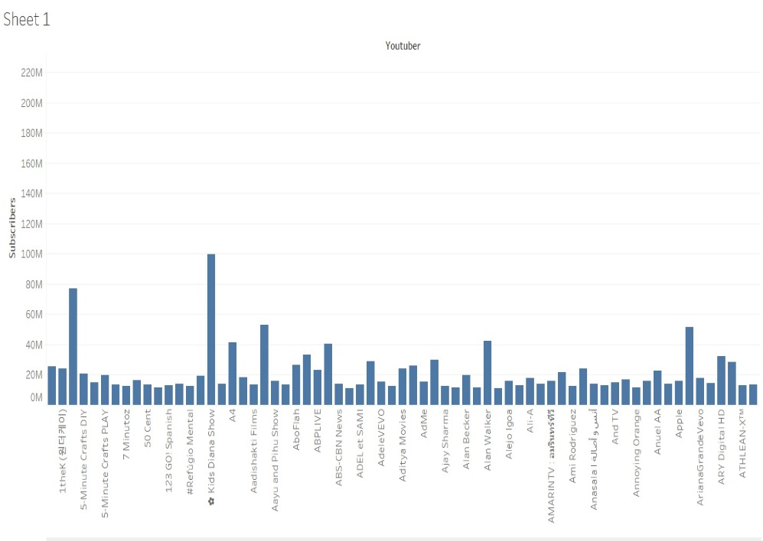

**HORIZONTAL BAR CHART**

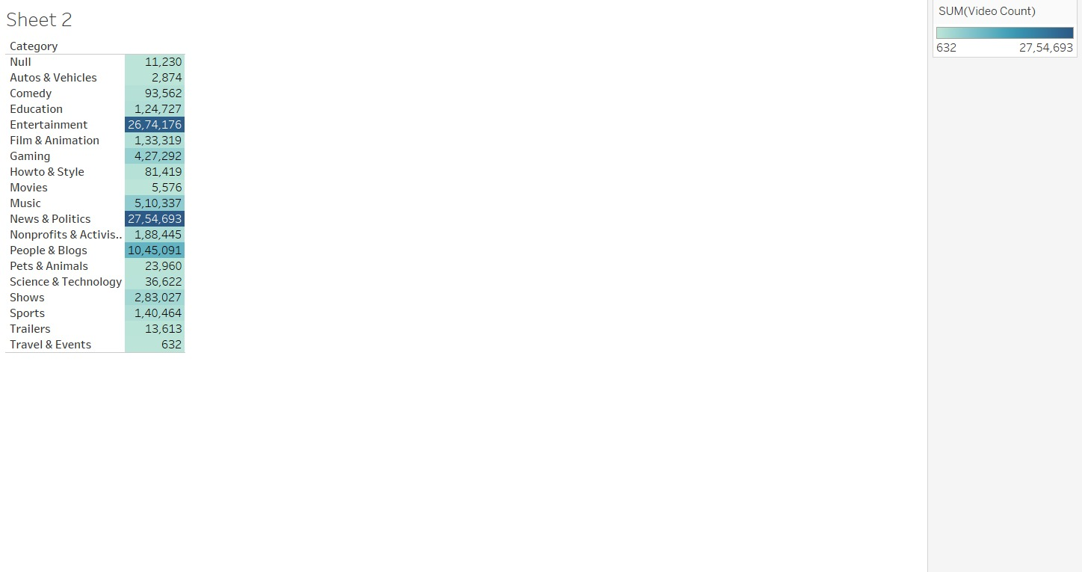

**HIGHLIGHTED TABLES**

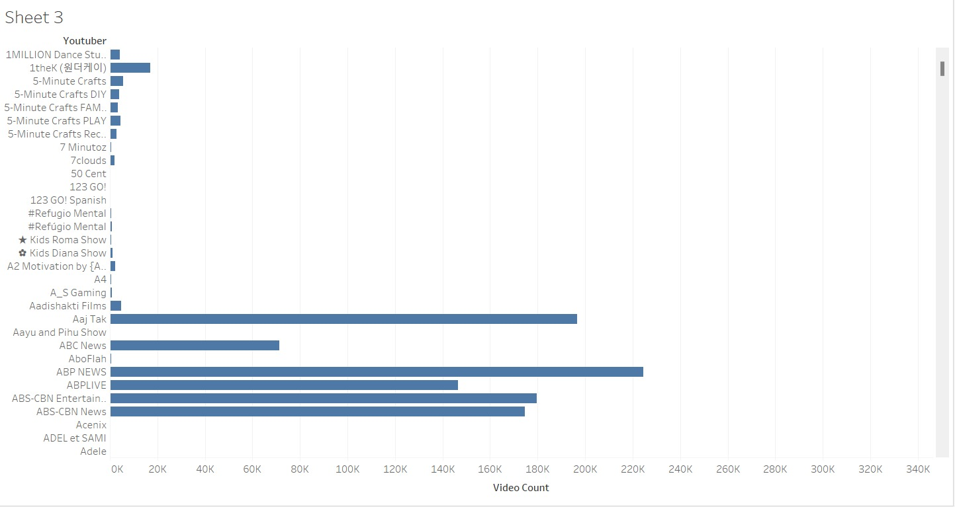

**HORIZONTAL BAR CHART**

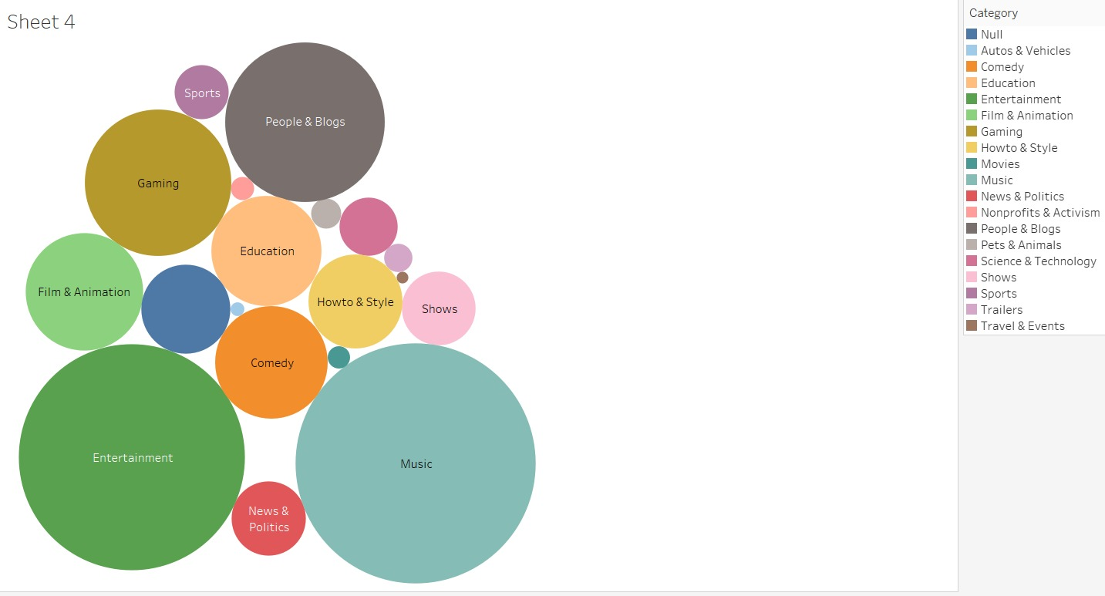 **BUBBLE CHART**

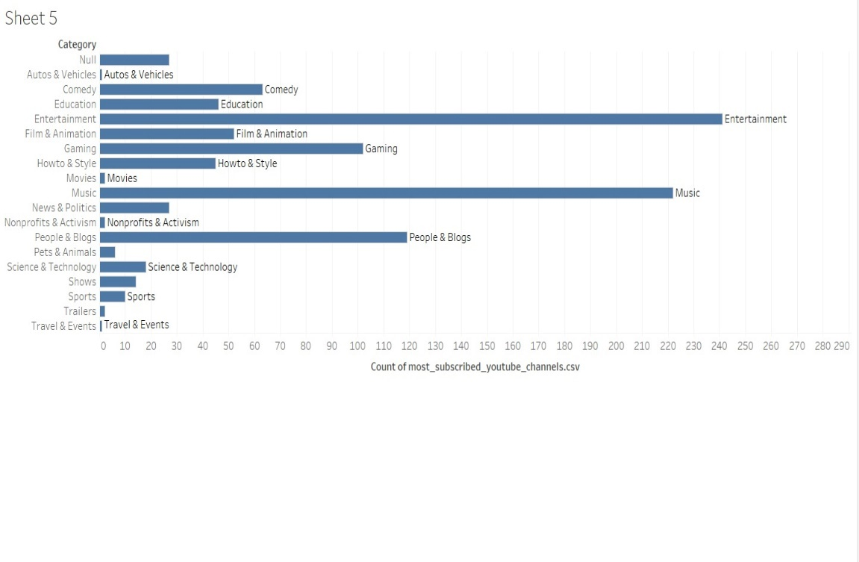

**HORIZONTAL BAR CHART**

**6.PROJECT PLANNING AND SCHEDULING**

6.1 Sprint Planning and Estimation

Sprint planning and estimation are essential elements in the project management process for "Exploring the World of YouTube Channels." In Agile methodologies, such as Scrum, sprint planning involves selecting a set of tasks to be completed during a sprint, while estimation helps determine the effort required for each task. Here's how this can be applied to the project:

1. Product Backlog Refinement:

Before each sprint planning, the product backlog, a prioritized list of features and tasks, should be reviewed and refined. In the context of your project, this would include tasks related to data collection, categorization, analysis, recommendation algorithms, and user interface enhancements.

1. Sprint Goals:

Define the specific objectives for the upcoming sprint. These goals should be aligned with the project's overall objectives, such as improving data analysis, enhancing recommendation accuracy, or refining the user interface.

1. Task Selection:

Based on the sprint goals and the product backlog, select a set of tasks to be completed during the sprint. These tasks should be well-defined and directly contribute to achieving the sprint goals.

1. Estimation:

Use estimation techniques like story points, ideal days, or hours to estimate the effort required for each selected task. For example, data collection tasks may require more effort than minor UI enhancements.

1. Sprint Planning Meeting:

Conduct a sprint planning meeting with the project team. During this meeting, the tasks to be completed in the sprint are discussed, and team members commit to completing specific tasks.

1. Task Breakdown:

Break down complex tasks into smaller subtasks. For example, if one of the sprint tasks is to enhance data collection, subtasks may include setting up API endpoints, data storage, and data retrieval scripts.

1. Task Assignment:

Assign team members to specific tasks based on their expertise and availability.

1. Definition of Done:

Clearly define the criteria that indicate when a task is considered "done." For example, a data analysis task may be considered done when a report is generated and validated for accuracy.

1. Sprint Duration:

Determine the duration of the sprint. Typically, sprints in Scrum last 2-4 weeks. The choice of sprint duration depends on the project's complexity and team capacity.

1. Sprint Review and Retrospective:

At the end of the sprint, conduct a sprint review to demonstrate completed work to stakeholders. Also, hold a sprint retrospective to identify areas for improvement in the next sprint.

1. Adjusting the Backlog:

Based on the outcomes of the sprint and feedback from the sprint retrospective, adjust the product backlog and priorities as necessary for future sprints.

**7. CODING AND SOLUTIONING**

from ydata_profiling import ProfileReport

import pandas as pd

df = pd.read_csv('youtube.csv')

df.head()

report = ProfileReport(df, title = "YouTube Analytics")

report.to_file('Report.html')

**8. ADVANTAGES & DISADVANTAGES**

**Advantages:**

1. Content Discovery: Users can easily discover new and interesting YouTube channels that align with their interests and preferences, leading to a more engaging and personalized experience.
2. Diverse Insights: The project offers insights into the diverse range of content available on YouTube, allowing users to explore various topics, genres, and cultural perspectives.
3. Enhanced User Experience: By providing personalized recommendations and user-centric features, the project improves the overall user experience and satisfaction.
4. Creators Opportunities: Content creators benefit from increased visibility, as their channels are more likely to be discovered by a relevant audience. This can enhance their reach and impact.
5. Data-Driven Decision-Making: The project's data analysis provides valuable insights for content creators and marketers, helping them make data-driven decisions to improve content and engagement.
6. Cultural and Societal Insights: The assessment of the societal and cultural impact of YouTube channels can offer valuable insights into trends, behavior, and cultural shifts influenced by digital content.

**DISADVANTAGES:**

1. Algorithmic Bias: The recommendation algorithms may inadvertently introduce bias, potentially leading to filter bubbles where users are exposed only to content that aligns with their existing beliefs and preferences.
2. Data Privacy Concerns: The collection and analysis of user data for recommendations can raise concerns about data privacy and security, requiring strict data protection measures.
3. User Engagement Challenges: Despite recommendations, user engagement and satisfaction may vary, as individual tastes and preferences are not entirely predictable, and users may encounter content that does not resonate with them.
4. Algorithm Limitations: Recommendation algorithms may not always capture the complexity of user preferences, leading to inaccurate or unsatisfactory recommendations.
5. Content Quality: While the project aims to discover a wide range of channels, it may inadvertently promote low-quality or controversial content if algorithms prioritize popularity over quality.

**9. CONCLUSION**

In an age marked by the digitization of content and the emergence of online platforms, YouTube has undeniably asserted itself as a global behemoth, offering a diverse and ever-expanding universe of content. The "Exploring the World of Top YouTube Channels" project has ventured into this digital terrain, seeking to understand, categorize, and offer recommendations within the boundless realm of YouTube. This project has not only provided a lens through which we can perceive the multifaceted dimensions of YouTube but has also underscored the intrinsic advantages and challenges inherent to the endeavor of exploring such an expansive digital ecosystem. The journey began with data collection, an initial step in comprehending the vast expanse of YouTube's content. We sourced datasets that encapsulated user ratings across a myriad of movies, essential for collaborative filtering—a fundamental technique underlying our recommendation engine. As our project unfolded, the complexities and intricacies of the YouTube universe came to the fore. Through data preprocessing, we grappled with the inherent imperfections of data—missing values, duplicates, and outliers. This was a pivotal phase in ensuring the robustness of our recommendation algorithms and the accuracy of our findings.

Two main approaches, user-based and item-based collaborative filtering, formed the crux of our recommendation system. The former sought to identify users with similar tastes and recommend content enjoyed by their peers, whereas the latter focused on suggesting movies similar to those previously appreciated by the user. These collaborative filtering techniques, bolstered by recommendation algorithms, endeavored to provide a personalized and engaging viewing experience for YouTube users. The project was not confined to data analysis and recommendation algorithms alone; it ventured further to assess the societal and cultural impact of influential YouTube channels. This entailed evaluating trends in relation to consumer behavior, pop culture, and beyond—unearthing how digital content shapes and reflects the society we inhabit. Such insights offered a glimpse into the profound influence wielded by creators on the platform.

As we conclude this journey through the world of YouTube, it is clear that our digital landscape is in constant flux, with content, trends, and technologies ever-changing. Our understanding of this world, while growing deeper, remains incomplete. The beauty of this project lies in its adaptability and responsiveness to an ever-evolving environment. In essence, the "Exploring the World of Top YouTube Channels" project epitomizes the convergence of technology, creativity, and data, offering a unique vantage point from which to observe and appreciate the richness of our digital age. While it has unveiled the advantages and challenges intrinsic to navigating YouTube's vast expanse, it also signifies the limitless possibilities that emerge when data, technology, and human creativity intersect—a truly dynamic and ever-enticing confluence of the digital world.

**10. FUTURE SCOPE**

The future scope of this research project, extends beyond its immediate objectives, the project's scope can be extended and refined to embrace new challenges and opportunities. Here are some key avenues for future development:

1. Integration of Advanced Machine Learning and AI: Incorporating advanced machine learning models, such as deep learning and reinforcement learning, can enhance the accuracy of recommendations. AI-driven approaches can adapt in real-time to changing user preferences and evolving content.
2. Real-time Updates and Notifications: Developing a feature that provides real-time updates on newly uploaded videos from subscribed channels or personalized notifications for content matching a user's interests can boost user engagement and retention.
3. Enhanced User Profiling: Expanding user profiles to encompass a broader range of user data, including demographic information, location, and historical interactions, can create more refined recommendations and a deeper understanding of user preferences.
4. Content Quality Assessment: Implementing algorithms that assess the quality and credibility of content can help users differentiate between reliable and unreliable sources, especially in the context of news or educational content.
5. Cross-Platform Integration: Extending the project's capabilities to cover other digital platforms, such as social media or streaming services, can provide a more comprehensive view of a user's digital interactions and preferences.
6. Education and Learning Channels: Focusing on enhancing the recommendation system for educational and e-learning channels can have a significant impact, especially in the context of online education.

**11.APPENDIX**

CODE is Available at: